Flapmax Unveils Women in AI Fellowship on Generative AI – FAI Institute
FAI Institute’s WAI program now accepting applications for 3rd cohort; short documentary film on Women in AI showcases program’s success

Tampa, Florida, Mar. 8, 2024 — Flapmax, a leading innovator in artificial intelligence solutions, today announced the launch of its Women in AI (WAI) Generative AI Fellowship program as part of its FAI Institute initiative. The program aims to empower women in the field of artificial intelligence (AI) and drive innovation in AI research and development, inclusive of underserved communities in emerging markets like Africa. Applicants with interests in generative AI are invited to apply by April 8, 2024 to participate in the program’s 3rd cohort, starting May 2024.

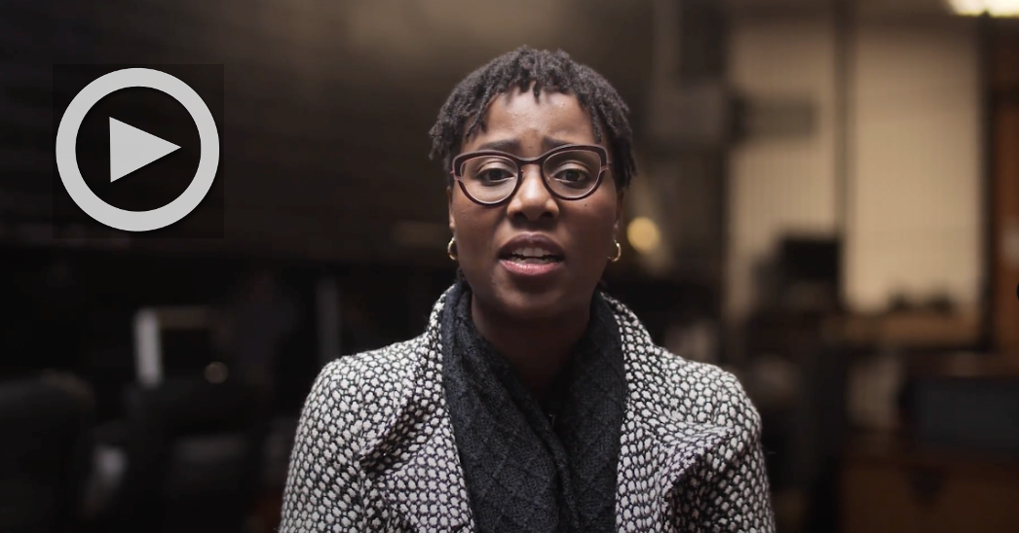
[VIDEO LINK]: https://tinyurl.com/WaiShortDocu
[CAPTION]: Women’s History Month - WAI short film documentary
AI talent is in demand as other tech job listings decline. The Wall Street Journal reports in an article published March 5, 2024, that while IT-related job posts are down by 31%, postings for AI-related roles are growing, up 42%, and touting higher pay. Despite this surge, the representation of women in critical roles such as AI Researchers, AI Engineers, and Cloud Specialists remains alarmingly low, accounting for only about 18%. In response to this disparity, a transformative initiative is underway to enhance access to resources and opportunities for aspiring female professionals.

"At FAI Institute, our mission is to advance human potential through cutting-edge research, education, and training programs built for the workforce of the future," said Dr. Dave Ojika, founder of FAI Institute. "We recognize the immense potential of women in driving innovation and progress in the AI field. Through concerted efforts to provide access to quality training, mentorship, and opportunities, we are committed to empowering women to thrive in AI careers and contribute meaningfully to the industry.”

Since its inception, the FAI Institute’s WAI initiative has provided training opportunities for more than 800 women from over 24 countries. Supported by Intel and Microsoft, and in collaboration with Wentors, a global community dedicated to the growth of women in technology, the WAI initiative is expanding opportunities for underrepresented communities, especially women, through experiential learning and hands-on projects in real-world contexts. In celebration of International Women's Day, WAI program graduates shared their experiences in a short documentary film released today, titled Breaking Barriers: Women Shaping the Future of AI.

“FAI Institute's Women in AI training program is a wonderful initiative that has given women the opportunity to grow in artificial intelligence and data,” said Dorathy Simeon, Senior Programs Coordinator at Wentors. “In a world becoming increasingly aware of the possibilities that AI presents, such an effort becomes the more relevant than ever.”

This year’s WAI program, launching in May, includes a 4-week virtual course with hands-on labs, teaching industry tools for practical AI solutions. Participants will analyze large datasets and use machine learning libraries to develop AI models for business. After the course, they are matched with 8-week AI practicum projects, mentored by industry experts. Peer groups and weekly meetings will provide guidance, while participants network with tech professionals to expand their portfolios and showcase achievements.

FAI Institute continues its vision of premier university-quality research with industry-scale impact. The initiative is creating partnerships that help ignite technology growth in underrepresented communities. FAI Institute organizes FAI Summit, fostering a community dedicated to responsible AI research, emerging tech, and sustainability, while creating an avenue to collaborate with researchers, governments, entrepreneurs, and top corporations. Working with these partners, FAI Institute is helping connect the next generation of innovators with sustainable technology goals and cutting-edge career skills through programs like WAI.

The WAI 2024 program is prioritizing applicants with an interest in generative AI. Applicants may be university/college students or working professionals, have some fundamental knowledge of data science or computer programming, and be available for the full program: May – August 2024. Successful applicants will be shortlisted to cast in a feature film that will leverage AI and creative tech in the filmmaking process. Further details on this opportunity will be announced soon.

To learn more about getting involved with the Women in AI program or FAI Institute, please visit www.fai.institute.

About FAI Institute
FAI Institute by Flapmax is a pioneering research and development initiative dedicated to advancing the field of artificial intelligence and other advanced technologies through cutting-edge research, education, collaboration, and exploration. Committed to fostering equity and fairness in AI, the initiative provides a dynamic platform for researchers and industry professionals to engage in innovative AI research. With a focus on interdisciplinary collaboration and sustainability, FAI Institute aims to drive transformative progress in AI technology and its impact on society.

About Flapmax
Flapmax is a data and AI technology company partnering with leading technology providers around the globe to identify and accelerate to market sustainable technology solutions that improve communities worldwide. With a focus on AI-powered solutions that are global and sustainable, Flapmax is improving collaboration across borders and connecting innovators and businesses with digital transformation solutions, advanced AI models, and global partnerships.

Contact: marketing@fai.institute or visit www.fai.institute

